**VISVESVARAYA TECHNOLOGICAL UNIVERSITY BELAGAVI-590018, KARNATAKA**



**A MINI PROJECT REPORT**

ON

**"Campus Connect Management System”**

Submitted in partial fulfillment of requirements for the award of 5th semester,

**BACHELOR OF ENGINEERING**

**IN**

**COMPUTER SCIENCE & ENGINEERING**

Submitted By:

**Anand Kumar Singh**

**(USN: 1MJ16CS015)**

Under the Guidance of

**Ms. Sahana**

**Assistant Professor,**

**Department of Computer Science & Engineering**



**DEPARTMENT OF COMPUTER SCIENCE & ENGINEERING**

**MVJ COLLEGE OF ENGINEERING**

**BENGALURU-67**

**2018-19**

**MVJ COLLEGE OF ENGINEERING**

**Channasandra, Near ITPB, Bangalore-67**

**Department of Computer Science and Engineering**



***Certificate***

This is to certify that the mini project entitled **"Campus Connect Management System”** is a bona fide work carried out by **Anand Kumar Singh(1MJ16CS015)**abonafide student of MVJ College of Engineering in partial fulfillment for the award of degree of Bachelor of Engineering in Computer Science & Engineering of the VisvesvarayaTechnological University, Belagavi during the year 2018-19. It is certified that all the corrections/suggestions indicated for Internal Assessment have been incorporated in the Report. The mini Project Report has been approved as it satisfies the academic requirements in respect of Project work prescribed for the said degree.

|  |  |  |
| --- | --- | --- |
| **Signature of the Guide** |  | **Signature of the HOD** |
|  |  |  |

**Signature of the Examiners**

***........................................... ............................................***

**Internal External**

**ABSTRACT**

This project is best on online resource exchange. Here anyone can register him/herself as a buyer or seller. As a Seller, he/she can advertise their products like books, laptops, phones, etc. And as a Buyer, he /she can also see all the product uploaded on the site for advertisement.

If anyone is interested in buying some product then he/she can chat with the uploader of the advertisement and can finalize the price or can finalize the deal.

CampConnect.com is a free local classified site specially designed for College Campuses. Sell anything like mobiles, laptops and Books(Notes). Submit ads for free. If you want to buy something - here you will find interesting items, cheaper than in the store. Start buying and selling in the most easy way on CampConnect.com.

**ACKNOWLEDGEMENT**

The satisfaction and euphoria that accompany the successful completion of any task would be incomplete without the mention of the people who made it possible, whose constant guidance and encouragement crowned our effort with success.

I express my sincere gratitude to our Principal **Dr.Nagaraj Sitaram**, & Vice Principal **Mrs.M.Brindha** MVJ College of Engineering for providing facilities.

I wish to place on record my grateful thanks to **Mrs. Mani Mozhi**, Head of the Department, Computer Science and Engineering, MVJ College of Engineering, Bangalore for providing encouragement and guidance.

I consider it a privilege and honour to express my sincere gratitude to my guide Ms**. Sahana CSE** Department of Computer Science & Engineering for their valuable guidance throughout the tenure of this seminar work and whose support and encouragement made this work possible.

I wish to thank the faculty of Computer Science and Engineering department whose suggestions have enabled me to surpass many of the seemingly impossible hurdles.

Thank you.

**TABLE OF CONTENT**

**CHAPTERS PAGE NO'S.**

**Chapter 1 Introduction 1**

**Chapter 2 System Requirement 2**

2.1 Hardware Requirements

2.1.1 Windows

2.1.2 Mac

2.2 Software Requirements

**Chapter 3 Problem Description 3**

**Chapter 4 System & Design 7**

4.1 ER Diagram

4.2 Schema Diagram

4.3 Normal forms

4.3.1 First normal form

4.3.2 Second normal form

4.3.3 Third normal form

**Chapter5 Implementation 10**

5.1 Login page

5.2 Configuration file

5.3 Book purchase

5.4 Send message

**Chapter 6 Screenshots 15**

6.1 Login

6.2 Navigation bar

6.3 Advertise

6.4 Purchase

**Chapter 7 Conclusion & Future scope 20**

7.1 Conclusion

7.2 Future Scope

**BIBLIOGRAPY 21**

**LIST OF FIGURES**

**Fig Number Fig Name Chapter No Page No**

4.1 ER diagram for Campus 4 7

connect Management system

4.2 Schema Diagram for 4 8

Campus Connect

Management system

6.1.1 login page 6 15

6.1.2 Registration 6 15

6.2.1 Home page 6 16

6.2.2 Message 6 16

6.2.3 My products 6 17

6.2.4 Bought products 6 17

6.3.1 Laptop advertisement 6 18

6.4.1 Mobile purchase 6 18

6.4.2 Laptop purchase 6 19

6.4.3 Book purchase 6 19

**LIST OF TABLES**

**Table Number Table Name Chapter No Page No**

3.1 user 3 3

3.2 author 3 4

3.3 advertisement 3 4

3.4 mobile 3 4

3.5 laptop 3 5

3.6 book 3 5

3.7 messages 3 6

**Chapter 1**

**INTRODUCTION**

This project is a free local classified site specially designed for College Campuses. Sell anything like mobiles, laptops and Books (Notes). Submit ads for free. If you want to buy something - here you will find interesting items, cheaper than in the store. Start buying and selling in the most easy way on CampConnect.

This project is best on online resource exchange. Here anyone can register him/herself as a buyer or seller. As a Seller, he/she can advertise their products like books, laptops, phones, etc. And as a Buyer, he /she can also see all the product uploaded on the site for advertisement.

If anyone is interested in buying some product then he/she can chat with the uploader of the advertisement and can finalize the price or can finalize the deal.

This is specially designed of students of a particular campus who can exchange books, laptops, mobile phones, calculators, and other study related material or anything with other students of same campus only. This is the reason why this project is named as CampConnect because it connects students with each other for exchanging resources by posting the advertisements, seeing others advertisements and if it is found to be useful for that particular student then he/she can message the uploader of the advertisement to buy the resource at more cheaper price than the market.

Even they can negotiate on the prices to finalize the deal. And once the deal is finalized and the item is sold to someone then owner can specify the name and details of the person to whom it is sold.

**Chapter 2**

**SYSTEM REQUIREMENTS**

2.1 Hardware Requirements

2.1.1 Windows

* Operating System : Windows 7 or later
* Processor : Intel Pentium or later
* Memory : 2 GB minimum, 4 GB recommended
* Screen resolution : 1280*1024 or larger
* Application Window Size : 1024*680 or larger
* Internet Connection : Not Required

2.1.2 Mac

* Operating System : Mac OS X 10.9.x or later
* Processor : Intel
* Memory : 2 GB minimum, 4 GB recommended
* Screen resolution : 1280*1024 or larger
* Application Window Size : 1024*680 or larger
* Internet Connection : Not Required

2.2 Software Requirements

* Client : Operating System(any)
* Server : apache server
* Database : MYSQL
* Language : PHP

**Chapter 3**

**PROBLEM DESCRIPTION**

CampConnect.com is a free local classified site specially designed for College Campuses. Sell anything like mobiles, laptops and Books(Notes). Submit ads for free. If you want to buy something - here you will find interesting items, cheaper than in the store. Start buying and selling in the mosteasy way on CampConnect.com.

The tables created for the system is as follows:

* USER
* AUTHOR
* ADVERTISEMENT
* MOBILE
* LAPTOP
* BOOK
* MESSAGES

The description of table is as follows:

Table 3.1 USER

|  |  |  |  |
| --- | --- | --- | --- |
| **COLUMN NAME** | **DATATYPE & SIZE** | **CONSTRAINTS** | **DESCRIPTION** |
| NITC_EMAIL_ID | VARCHAR(255) | PRIMARY KEY | EMAIL ID OF USER |
| USER_NAME | VARCHAR(255) | NOT NULL | USERNAME |
| MOBILE_NO | VARCHAR(255) | NOT NULL | PHONE NUMBER OF USER AS DETAIL |
| USER_TYPE | VARCHAR(255) | NOT NULL | TYPE OF USER |
| USER_PASSWORD | VARCHAR(255) | NOT NULL | USER PASSWORD |

Table 3.2 AUTHOR

|  |  |  |  |
| --- | --- | --- | --- |
| **COLUMN NAME** | **DATATYPE & SIZE** | **CONSTRAINTS** | **DESCRIPTION** |
| PRODUCT_ID | INT(100) | PRIMARY KEY | PRODUCT IDENTIFIER |
| AUTHOR_NAME | VARCHAR(255) | NOT NULL | NAME OF THE AUTHOR |

Table 3.3 ADVERTISEMENT

|  |  |  |  |
| --- | --- | --- | --- |
| **COLUMN NAME** | **DATATYPE & SIZE** | **CONSTRAINTS** | **DESCRIPTION** |
| ADVT_ID | INT(100) | PRIMARY KEY | ADVERTISEMENT IDENTIFIER |
| ITEM_NAME | VARCHAR(255) | NOT NULL | NAME OF ITEM |
| ITEM_TYPE | VARCHAR(255) | NOT NULL | TYPE OF ITEM |
| DATE_OF INIT | VARCHAR(255) | NOT NULL | DATE OF INITIATING |
| DATE_OF_EXP | VARCHAR(255) | NOT NULL | DATE OF EXPIRY |
| OWNER_ID | VARCHAR(255) | REFERENCES NITC_EMAIL_ID FROM USER | ID OF THE OWNER |
| BUYER_ID | VARCHAR(255) | REFERENCES NITC_EMAIL_ID FROM USER | ID OF THE BUYER |

Table 3.4 MOBILE

|  |  |  |  |
| --- | --- | --- | --- |
| **COLUMN NAME** | **DATATYPE & SIZE** | **CONSTRAINTS** | **DESCRIPTION** |
| PRODUCT_ID | INT(100) | PRIMARY KEY,REFERNCES ADVT_ID FROM ADVERTISEMENT | PRODUCT IDENTIFIER |
| MANUFACTURER | VARCHAR(255) | NOT NULL | NAME OF MANUFACTURER |
| MODEL_NAME | VARCHAR(255) | NOT NULL | MODEL NAME |
| YEAR_OF_PURCHASE | VARCHAR(255) | NOT NULL | PUCHASE YEAR |
| AD_DESCRIPTION | VARCHAR(255) | NOT NULL | DESCRIPTION OF THE ADVERTISEMENT |
| EXPECTED_PRICE | VARCHAR(255) | NOT NULL | EXPECTED PRICE |
| IMAGE_PATH | BLOB | NOT NULL | PATH OF THE IMAGE |

Table 3.5 LAPTOP

|  |  |  |  |
| --- | --- | --- | --- |
| **COLUMN NAME** | **DATATYPE & SIZE** | **CONSTRAINTS** | **DESCRIPTION** |
| PRODUCT_ID | INT(100) | PRIMARY KEY,REFERNCES ADVT_ID FROM ADVERTISEMENT | PRODUCT IDENTIFIER |
| MANUFACTURER | VARCHAR(255) | NOT NULL | NAME OF MANUFACTURER |
| MODEL_NAME | VARCHAR(255) | NOT NULL | MODEL NAME |
| YEAR_OF_PURCHASE | VARCHAR(255) | NOT NULL | PUCHASE YEAR |
| BATTERY_STATUS | VARCHAR(255) | NOT NULL | STATUS OF THE BATTERY |
| AD_DESCRIPTION | VARCHAR(255) | NOT NULL | DESCRIPTION OF THE ADVERTISEMENT |
| EXPECTED_PRICE | VARCHAR(255) | NOT NULL | EXPECTED PRICE |
| IMAGE_PATH | VARCHAR(255) | NOT NULL | PATH OF THE IMAGE |

Table 3.6 BOOK

|  |  |  |  |
| --- | --- | --- | --- |
| **COLUMN NAME** | **DATATYPE & SIZE** | **CONSTRAINTS** | **DESCRIPTION** |
| PRODUCT_ID | INT(100) | PRIMARY KEY,REFERNCES ADVT_ID FROM ADVERTISEMENT | PRODUCT IDENTIFIER |
| NAME_OF _BOOK | VARCHAR(255) | NOT NULL | NAME OF BOOK |
| CONDITION_BOOK | VARCHAR(255) | NOT NULL | CONDITION OF BOOK-STATUS |
| AD_DESCRIPTION | VARCHAR(255) | NOT NULL | DESCRIPTION OF THE ADVERTISEMENT |
| EXPECTED_PRICE | VARCHAR(255) | NOT NULL | EXPECTED PRICE |
| IMAGE_PATH | VARCHAR(255) | NOT NULL | PATH OF THE IMAGE |

Table 3.7 MESSAGES

|  |  |  |  |
| --- | --- | --- | --- |
| **COLUMN NAME** | **DATATYPE & SIZE** | **CONSTRAINTS** | **DESCRIPTION** |
| MSG_ID | INT(100) | PRIMARY KEY | MESSAGE IDENTIFIER |
| SENDER_ID | VARCHAR(255) | REFERENCES NITC_EMAIL_ID FROM USER | SENDER ID NUMBER |
| RECEIVER_ID | VARCHAR(255) | REFERENCES NITC_EMAIL_ID FROM USER | RECEIVER ID NUMNER |
| MESSAGE | VARCHAR(255) | NOT NULL | FULL MESSAGE |
| MSG_DATE | VARCHAR(255) | NOT NULL | DATE & TIME OF MESSAGE |

**Chapter 4**

**SYSTEM DESIGN**

4.1 ER Diagram

An Entity relationship diagram is a data modeling technique that graphically illustrates information system entities and the relationships between those entities.

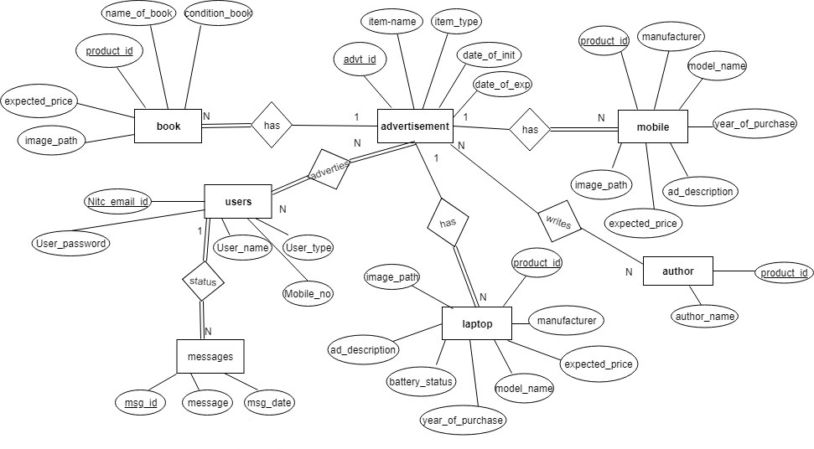

Fig 4.1

ER Diagram for CampConnect.

4.2 Schema Diagram

A database schema is a skeleton structure that represents the logical view of the entire database. It represents the foreign key references and primary keys.

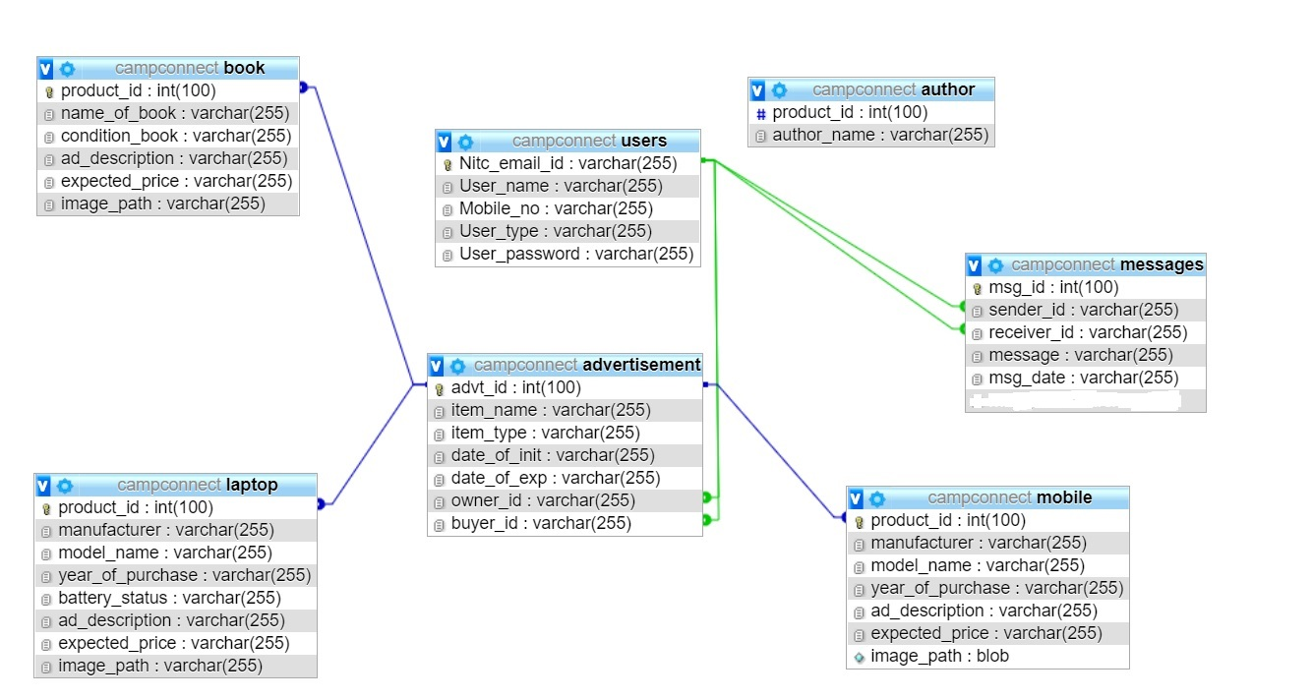

Fig 4.2

Schema Diagram for CampConnect.

4.3 Normal Forms

4.3.1 First Normal Form

Database is in first normal form, if it satisfies the following conditions

1. Contains only atomic values.

2. There are no repeating groups.

4.3.2 Second Normal Form

A relation schema R is in second normal form, if every non primary attribute A is fully functionally Dependant on Primary key of R

1. It is in 1NF

2. All non-key attributes are fully functionally dependant on primary key.

4.3.3 Third Normal Form

1. It is in 2NF

2. There are no transitive functional dependencies

The above tables satisfies all the Three Normal Forms

**Chapter 5**

**IMPLEMENTATION**

5.1 login page

<head>

<meta charset="utf-8">

<link rel="stylesheet" href="https://maxcdn.bootstrapcdn.com/bootstrap/3.3.7/css/bootstrap.min.css">

<link rel="stylesheet" type="text/css" href="css/global.css">

</head>

<body>

<!--<header class="login_h">

<h2>Rent IT On<h2>

</header>-->

<div class="container-fluid bg">

<div class="row">

<div class="col-md-4 col-sm-4 col-xs-12"></div>

<div class="col-md-4 col-sm-4 col-xs-12">

<!--form start-->

<form action='login.php' method="post" class="form-container">

<h1>Login Form</h1>

<div class="form-group">

<label for="exampleInputEmail1">Email address</label>

<input type="email" class="form-control" id="email" name="email" placeholder="Email" required>

</div>

<div class="form-group">

<label for="exampleInputPassword1">Password</label>

<input type="password" class="form-control" id="password" name="password" placeholder="Password" required>

</div>

<!--<div class="form-group">

<label for="exampleInputFile">File input</label>

<input type="file" id="exampleInputFile">

<p class="help-block">Example block-level help text here.</p>

</div>

<div class="checkbox">

<label>

<input type="checkbox"> Check me out

</label>

</div>-->

<br>

<input type="submit" id="submit" name="submit" value="Submit" class="btnbtn-success btn-block">

<br>

<p>If not Registered <a href="register.php">Click Here</a></p>

</form>

<!--form ends-->

</div>

<div class="col-md-4 col-sm-4 col-xs-12"></div>

</div>

</div>

<?php

//$db = mysqli_connect('localhost','root','password','olx_schema');

require('inc/config.php');

if(isset($_POST['submit'])){

$email_address = mysqli_escape_string($db,$_POST['email']);

$password = mysqli_escape_string($db,$_POST['password']);

$query = "SELECT *FROM Users WHERE Nitc_email_id = '$email_address' AND User_password= '$password'";

$result = mysqli_query($db,$query);

if(mysqli_num_rows($result)==1){

$_SESSION['email'] = $email_address;

$_SESSION['success'] = "You are now logged in";

header('location: home.php');

}

else{

echo "<script type='text/javascript'>alert('Failed to Login! Incorrect Email or Password')</script>";

}

?>

5.2 Configuration file

<?php

session_start(); /* Session */

$db=mysqli_connect("localhost","root","","campconnect"); /*Database Connection*/

?>

5.3 Book purchase

<?php

$query1 = "SELECT * FROM advertisement ";

$result = mysqli_query($db,$query1);

while ($row = mysqli_fetch_assoc($result)) {

//echo $row["item_name"];

//echo $row["date_of_init"];

//echo $row["date_of_exp"];

//echo '<br>';

$id = $row["advt_id"];

$email_id = $row["owner_id"];

if($row["item_type"]==="Book"){

$query2 = "SELECT * FROM Book WHERE product_id = '$id'";

$result2 = mysqli_query($db,$query2);

$row2 = mysqli_fetch_assoc($result2);

$query3 = "SELECT * FROM Users WHERE Nitc_email_id = '$email_id'";

$result3 = mysqli_query($db,$query3);

$row3 = mysqli_fetch_assoc($result3);

$i=0;

$query4 = "SELECT * FROM Author WHERE product_id = '$id'";

$result4 = mysqli_query($db,$query4);

while($row4 = mysqli_fetch_assoc($result4)){

if($i==0){

$author1 = $row4["author_name"];

$i++;

}

else if($i==1){

$author2 = $row4["author_name"];

$i++;

}

else if($i==2){

$author3 = $row4["author_name"];

$i++;

}

}

/*$row4 = mysqli_fetch_assoc($result4);

$author = $row4["author_name"];

*/?>

5.4 Send Message

<?php

$email_id = $_SESSION['email'];

if(isset($_POST['submit'])){

$rec_email = mysqli_escape_string($db,$_POST['email_id']);

$message = mysqli_escape_string($db,$_POST['msg'] );

$query = "INSERT INTO Messages (sender_id,receiver_id,message) VALUES ('$email_id','$rec_email','$message')";

$result = mysqli_query($db,$query);

if($result){

echo "<script type='text/javascript'>alert('Message sent Successfully!')</script>";

}

else{

echo "<script type='text/javascript'>alert('Error in sending message!!! Please try again.')</script>";

}

}

?>

**Chapter 6**

**SCREENSHOTS**

6.1 Login

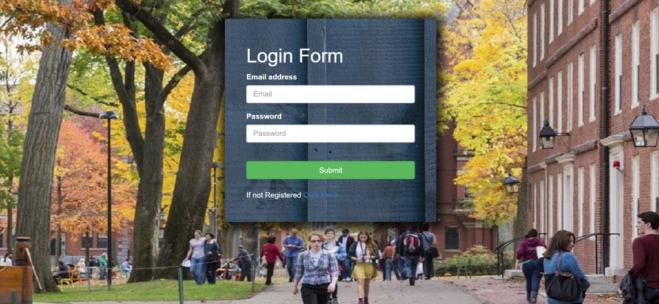

Fig 6.1.1 login page

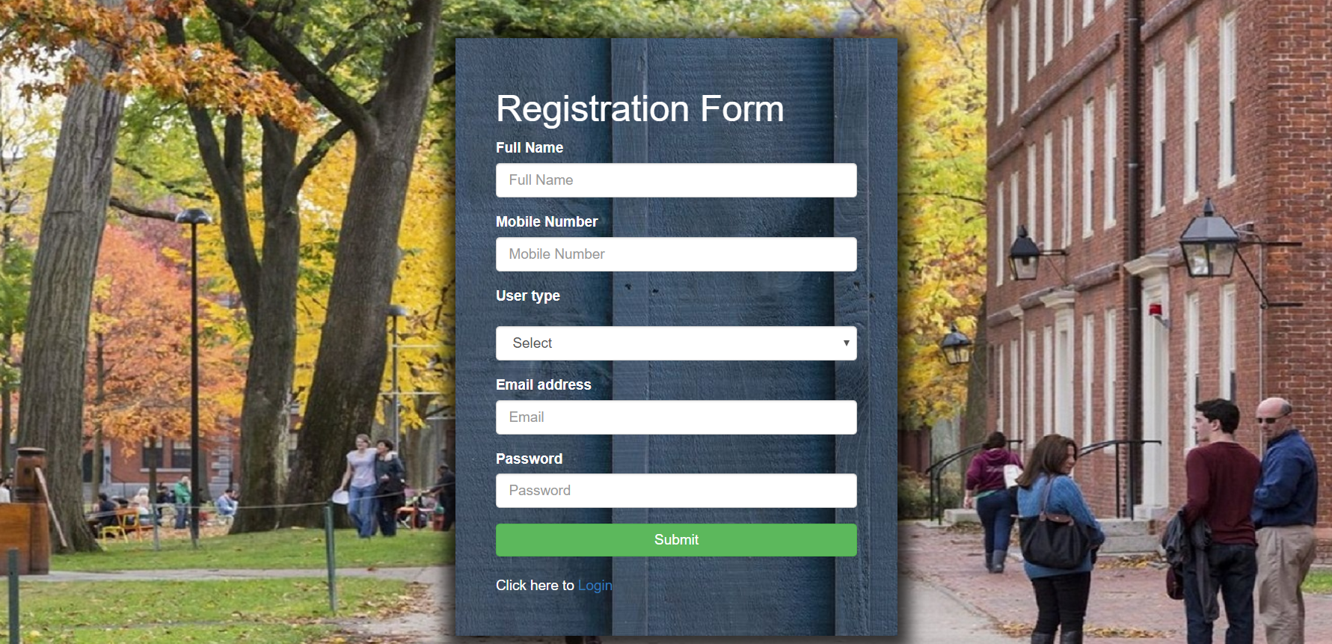

Fig 6.1.2 Registration

6.2 Navigation bar



Fig 6.2.1 Home page

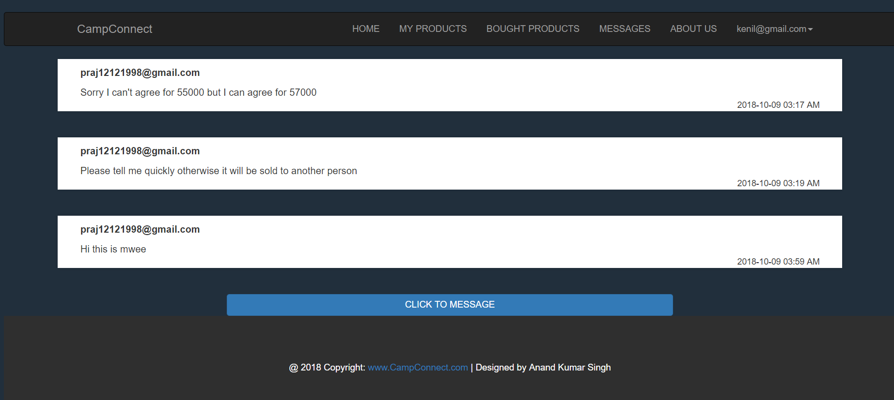

Fig 6.2.2 Message

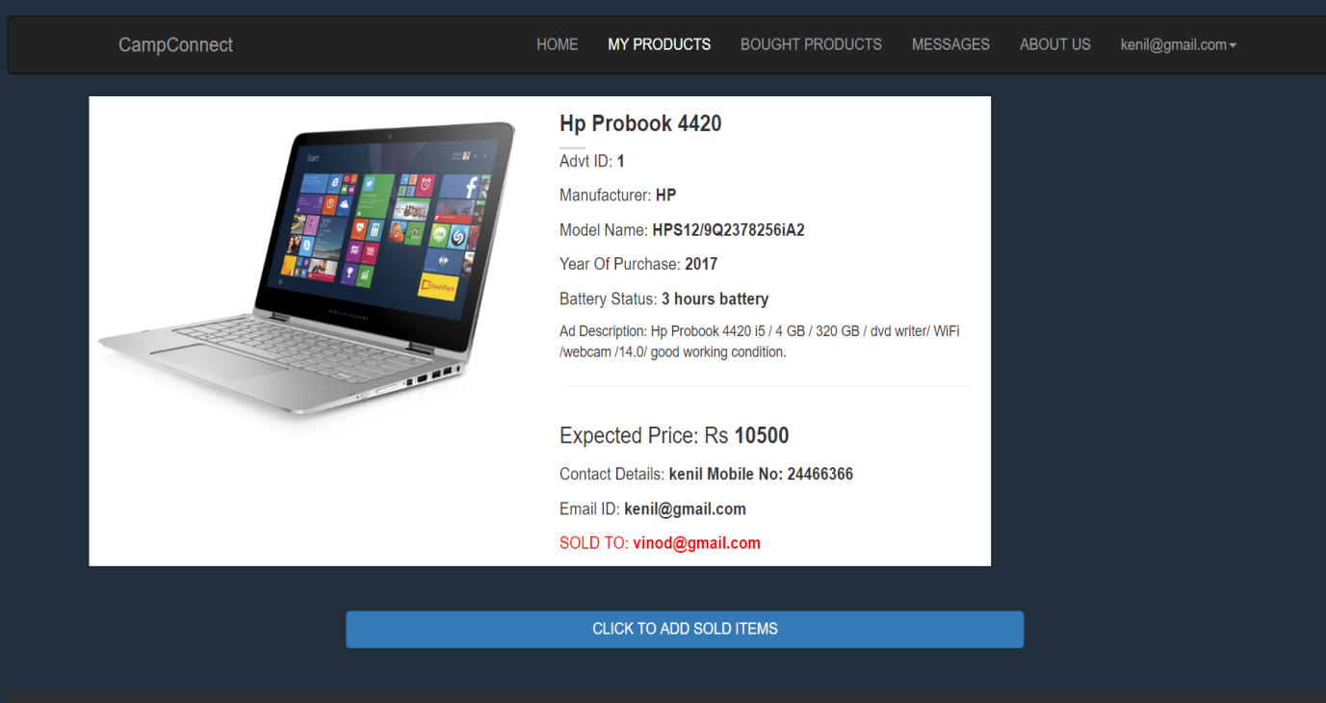

Fig 6.2.3 My products

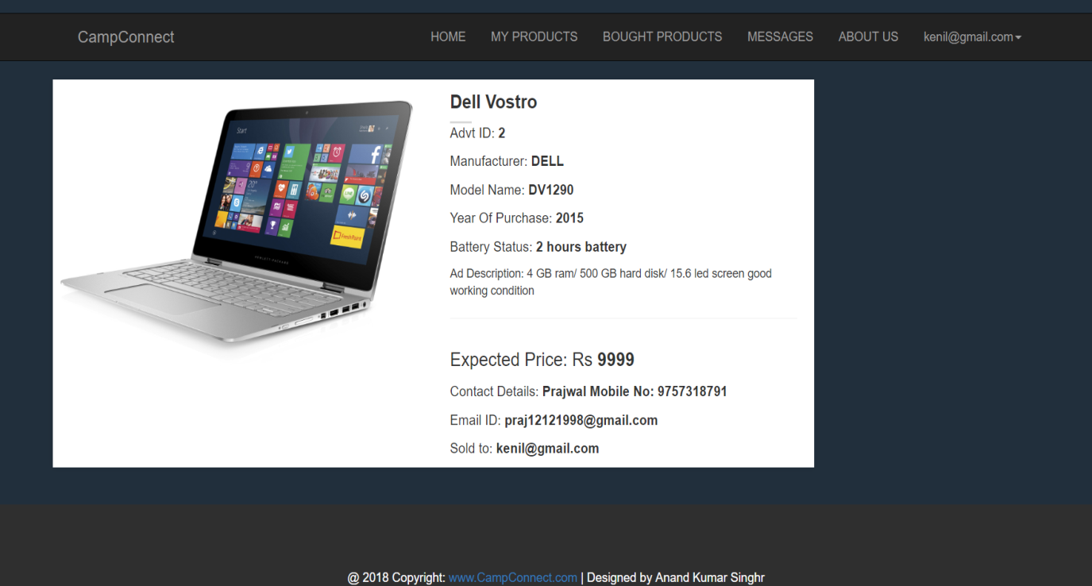

Fig 6.2.4 Bought products

6.3 Advertise

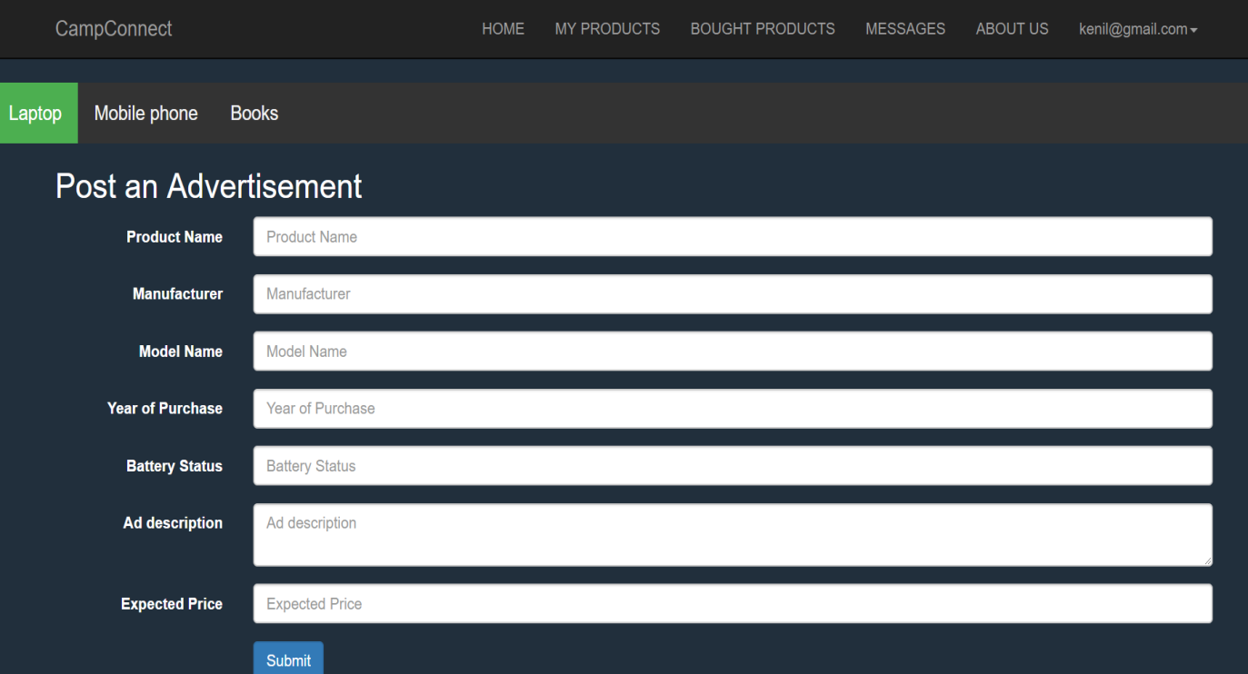

Fig 6.3.1 Laptop advertisement

6.4 Purchase

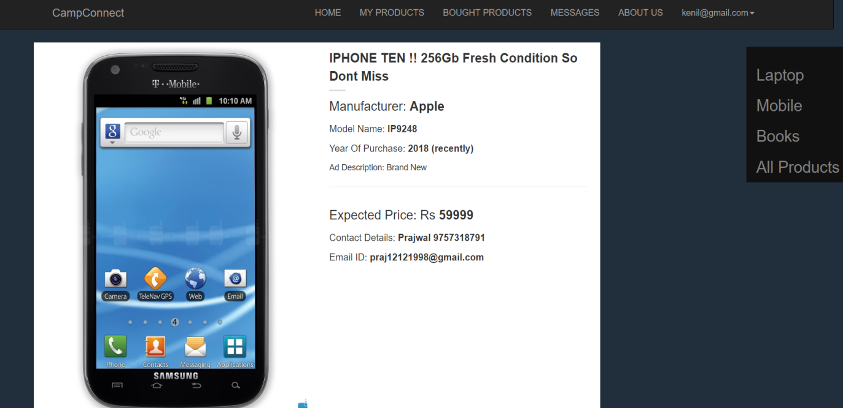

Fig 6.4.1 Mobile purchase

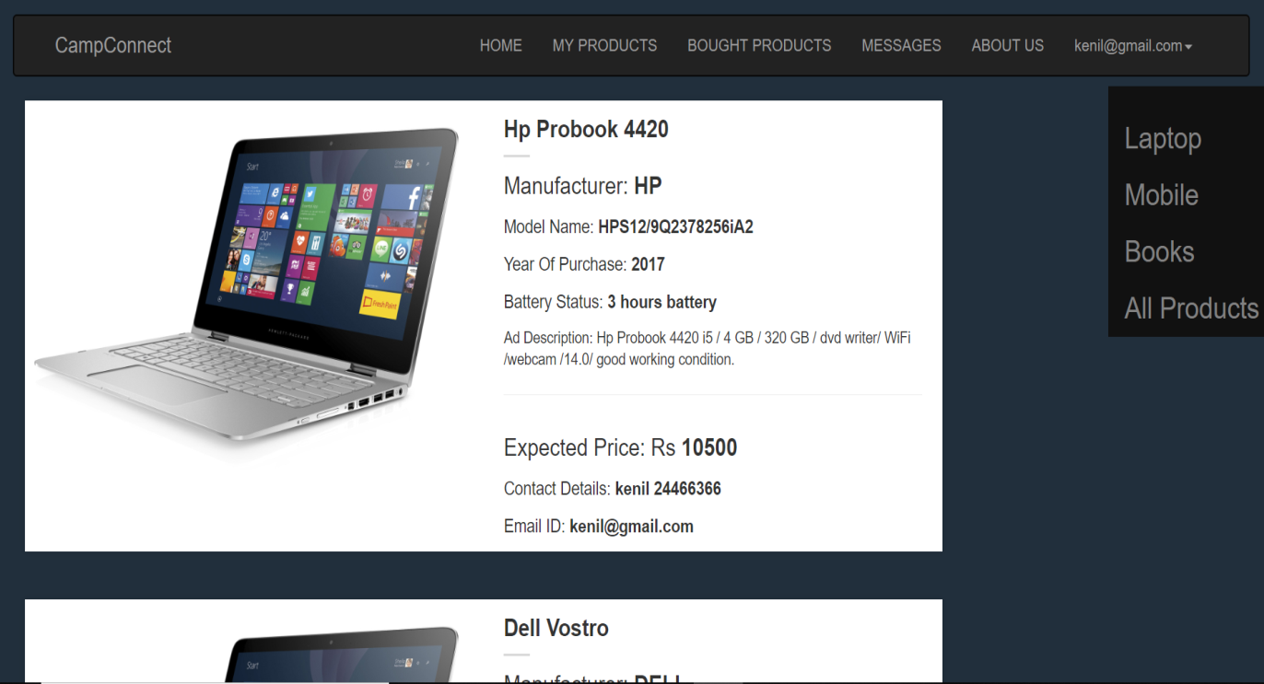

Fig 6.4.2 laptop purchase

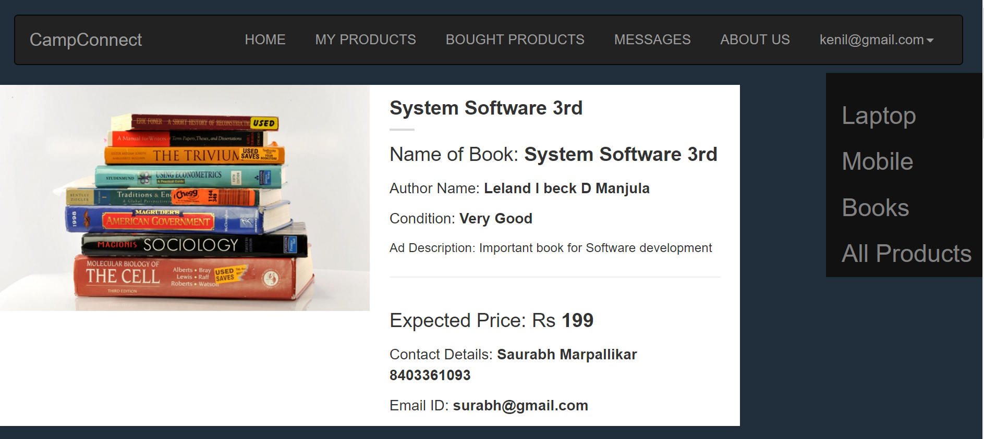

Fig 6.4.3 Book purchase

**Chapter 7**

**CONCLUSION AND FUTURE SCOPE**

7.1 Conclusion

CampConnect.com is a free local classified site specially designed for College Campuses. Sell anything like mobiles, laptops and Books(Notes). Submit ads for free. If you want to buy something - here you will find interesting items, cheaper than in the store. Start buying and selling in the most easy way on CampConnect.com.

7.2 Future Scope

* The system is based on web that could be expanded for the use as mobile app.
* More number of resources can be added in it for resources exchange.
* Area of application can also be developed for offices, homes, etc.

**BIBLIOGRAPHY**

During the course of making this project the books and materials required were taken from:

[1] Database systems Models, Languages, Design and Application Programming, RamezElmasri and Shamkant B. Navathe, 7th Edition, 2017, Pearson.

[2] <https://www.w3schools.com/>

[3] <https://www.youtube.com/>

[4] <http://www.mysqltutorial.org/php-calling-mysql-stored-procedures/>

[5] <http://www.mysqltutorial.org/mysql-triggers.aspx>